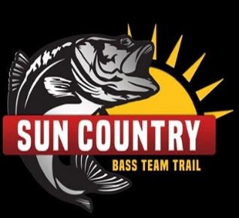 Contact: Kris Bosley (806) 674-7148

2021 Tournament Schedule
February 6th&7th Lake Amistad - Diablo East
March 20th&21st Lake O.H. Ivie - Elm Creek
April 10th&11th Hubbard Creek
May 15th&16th Possum Kingdom - Possum Hollow
Championship
June 13th-17th Hubbard Creek
Hubbard Creek will go off limits to all prefishing and obtaining information at sundown on May 16th. Official prefishing days are June 13th&14th. Tournament days are June 15th-17th.

Entry Fee = $300.00 All Events.
$50/Person Membership Fee.
Championship Qualification Rules: 1. Fish 3 of the 4 qualifying tournaments
2. Fish 2 tournaments w/same partner and pay for other 2
***In the event that 1 or more qualifying tournaments are cancelled, championship qualifying rules will be amended accordingly.
(3 qualifiers: Fish 2 or Fish one pay for other 2)
(2 Qualifiers: Fish 2 or Fish 1 and Pay for other 1)
(1 Qualifier: Fish 1 or pay for 1)
Please visit Sun Country Bass Team Trail on Face Book for more information and full set of rules.

